
FT/BIQP/1223/A 8-JUN-2023
FIRST TERM EXAMINATION (2023-24)
Subject: BIOLOGY  Grade: XII |  |  | Max. Marks:70  Time: 3 Hrs
Name: |  |  |  |  | Section: | Roll No:
General Instructions:
- This question paper consists of 6 printed pages.
- All answers to be written in the answer sheet provided.
- All questions are compulsory.
- The question paper has five sections: Section A, Section B, Section C , Section D and Section E. There are 33 questions in the question paper.
- Section–A has 16 questions of 1 mark each.
- Section–B has 5 questions of 2 marks each.
- Section–C has 7 questions of 3 marks each.
- Section D has 2 case study questions of 4 marks each.
- Section E has 3 Questions of 5 marks each.
- Wherever necessary, neat and properly labeled diagrams should be drawn.
 | SECTION A |  |  |  |  |  | 1*16
 | The lac operon consists of
 | a. | four regulatory genes only |  | b. | one regulatory gene and three structural genes
 | c. | two regulatory genes and two structural genes |  | d. | three regulatory genes and three structural genes.
2. | An environmental agent, which triggers transcription from an operon, is a
 | a. | depressor |  | b. | controlling element
 | c. | regulator |  | d. | inducer
3. | In the DNA molecule,
 | a. | the proportion of adenine in relation to thymine varies with the organism |  | b. | there are two strands which run anti- parallel-one in 5' 3' direction and other in 3'5'
 | c. | the total amount of purine nucleotides and pyrimidine nucleotides is not always equal |  | d. | there are two strands which run parallel in the 5' 3' direction.
4. | ABO blood grouping is controlled by gene I which has three alleles and show co-dominance. There are six genotypes. How many phenotypes in all are possible?
 | a. | Six |  | b. | Three
 | c. | Four |  | d. | Five
5. | In order to find out the different types of gametes produced by a pea plant having the genotype AaBb it should be crossed to a plant with the genotype
 | a. | AABB |  | b. | AaBb
 | c. | aabb |  | d. | aaBB
6. | Which of the following is a palindrome?
 | a. | 5' – GAATAC – 3'  3' – CTTATG – 5' |  | b. | 5' – GATATAC – 3'  3' – CTATATG – 5
 | c. | 5' – GAATTC – 3'  3' – CTTAAG – 5' |  | d. | All of these
7 | In gel electrophoresis, DNA are forced to move towards
 | a. | anode under magnetic field |  | b. | cathode under magnetic field
 | c. | anode under electric field |  | d. | cathode under electric field
8 | The figure shows DNA separated out, removed by :  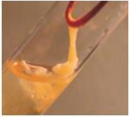
 | a. | spooning |  | b. | spooling
 | c. | spilling |  | d. | speeling
9 | - Suitable preservatives are added  - These formulations need clinical trials.  - Quality control testing is uniform for all the products.  How many of the above statements is incorrect?
 | a. | 0 |  | b. | 1
 | c. | 2 |  | d. | 3
10 | Non-transformants E.coli will-
 | a. | Grow in ampicillin and tetracycline  both |  | b. | Grow in ampicillin but not  tetracycline
 | c. | Grow in tetracycline but not  ampicillin |  | d. | Grow neither in tetracycline nor in  ampicillin
11 | Represented below is the inheritance pattern of a certain type of trait in humans.  Which one of the following conditions could be an example of this pattern?  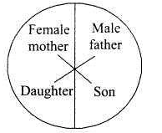
 | a. | Phenylketonuria |  | b. | Sickle cell anaemia
 | c. | Haemophilia |  | d. | Thalassemia
12 | Which one of the following conditions correctly describes the manner of determining the sex?
 | a. | Homozygous sex chromosomes (ZZ) determine female sex in birds. |  | b. | XO type of sex chromosomes determine male sex in grasshopper.
 | c. | XO condition in humans as found in Turner's syndrome, determines female sex. |  | d. | Homozygous sex chromosomes (XX) produce male in Drosophila
Question No. 13 to 16 consists of two statements – Assertion (A) and Reason (R). Answer these questions selecting the appropriate option given below:
a) Both A and R are true, and R is the correct explanation of A.
b) Both A and R are true, and R is not the correct explanation of A.
c) A is true but R is false.
d) If both Assertion and Reason are false.
13 | Assertion: In Mirabilis, selfing of F1 pink flower plants produces same phenotypic &  genotypic ratio.  Reason: Flower color gene shows incomplete dominance. |  |  |  |  |  | 1
14 | Assertion: In Griffith's experiment, a mixture of heat-killed virulent bacteria R and live non-virulent bacteria S, lead to the death of mice.  Reason: 'Transforming principle' got transferred from heat killed R strain to S strain and made it virulent. |  |  |  |  |  | 1
15 | Assertion: Recognition site should be preferably single and responsive to commonly used  restriction enzyme.  Reason: In PBR322 alien DNA is ligated generally in the area of Bam-HI site of  tetracycline resistance gene. |  |  |  |  |  | 1
16 | Assertion: The genetic codes are comma less.  Reason: Genetic codes are overlapping. |  |  |  |  |  | 1
 | SECTION B |  |  |  |  |  | 2*5
17. | What is the cross between the progeny of F1 and the homozygous recessive parent called? How is it useful? |  |  |  |  |  | 2
18. | The pedigree chart shown below shows a particular trait. Write your conclusions based on the pedigree.  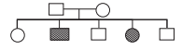 |  |  |  |  |  | 2
19 | The process of termination during transcription in a prokaryotic cell is being represented here. Name the label a, b, c and d.  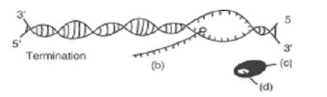 |  |  |  |  |  | 2
20 | Why is it essential that tRNA binds to both amino acids & mRNA codon during protein synthesis? |  |  |  |  |  | 2
21 | Mention two classes of restriction enzymes. Write their respective roles.  OR  Write any two properties of restriction endonuclease enzymes? |  |  |  |  |  | 2
 | SECTION -C |  |  |  |  |  | 3*7
22. | In Antirrhinum majus a plant with red flowers was crossed with a plant with white flowers. Work out all the possible genotypes & phenotypes of F1 & F2 generations comment on the pattern of inheritance in this case? |  |  |  |  |  | 3
23. | Mentions the advantages of selecting pea plant for Mendelian experiment.  OR  - What is co-dominance? Give an example.  - Write four symptoms of Turner’s syndrome. |  |  |  |  |  | 3
24. | Since DNA is a hydrophilic molecule, it cannot pass through cell membranes. Name and explain the technique with which the DNA is forced into (ii) a bacterial cell (ii) a plant cell (iii) an animal cell. |  |  |  |  |  | 3
25. | A selectable marker is used in the section of recombinants based on their ability to produce color in presence of chromogenic substrate.  (a) Mention the name of mechanism involved.  (b) Which enzyme is involved in the production of color?  (c) How is it advantageous than using antibiotic resistant gene as a selectable marker? |  |  |  |  |  | 3
26 | Who postulated an adapter molecule to link the genetic code and the amino acids?  State its two functions. |  |  |  |  |  | 3
27 | (i)What are the four levels at which gene expression is regulated in eukaryotic cell?  (ii)Name the regulatory gene of Lac –operon. |  |  |  |  |  | 3
28 | In a maternity clinic, for some reasons the authorities are not able to hand over the two newborns to their respective real parents. Name and describe the technique that you would suggest sorting out the matter. |  |  |  |  |  | 3
 | SECTION -D |  |  |  |  |  | 4*2
 | Q. No. 29 and 30 are case-based questions which has 3 subparts with internal choice in one subpart.
29. | 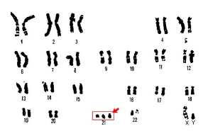  - This is a karyotype of a human suffering from chromosomal disorder. Name the disorder.  - What is the cause of this disorder?  OR  - Write about two symptoms of this disease.  - By which name is this syndrome also known? Why? |  |  |  |  |  | 4
30 | The diagram shows a setup for electrophoresis.  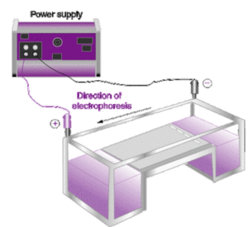  - Why is it needed in experiments in Molecular Genetics or Biotechnology?  - Write the principle behind the working of this apparatus.  OR  b) Draw a typical agarose gel electrophoresis with lane 1 to 4 with undigested and digested DNA fragments and show its anode and cathode ends.  c)What is elution? |  |  |  |  |  | 4
 | SECTION -E |  |  |  |  |  | 3*5
31 | a) Who performed the following experiment?  b) What was proved by this experiment?  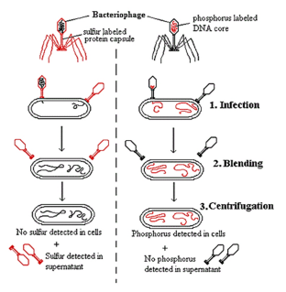  OR  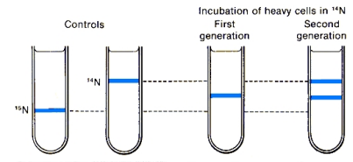  a) What was the objective of this experiment?  b) Who performed it?  c) How was the DNA separated into different layers?  d) Name any other scientist and the experimental material on which they had performed experiment to prove the same. |  |  |  |  |  | 5
32 | 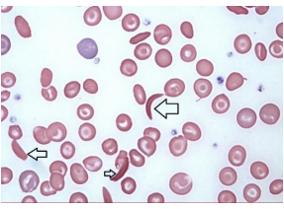  a) The slide shows a human blood smear. What is the patient suffering from? (Refer to arrows)  b) Is the disease sex linked?  c) Explain the genetic cause of this disease?  d) What is the probability of children being affected by the disease when both the parents are heterozygotes of this gene?  OR  - Draw any 6 Symbols used to prepare pedigree charts. Write what does those symbols represent?  - Why are pedigree charts important in studying inheritance patterns especially in human beings? |  |  |  |  |  | 5
33 | The development of bioreactors is required to produce large quantities of products.  (a) Give two optimum growth conditions used in bioreactors.  (b) Draw a well labelled diagram of simple stirred tank bioreactor.  (c) How does a simple stirred tank bioreactor differ from sparged stirred – tank’ bioreactor?  OR  With the help of a diagram explain Polymerase chain reaction. |  |  |  |  |  | 5
***

